**Exp-6 Design an obstacle detector and distance measuring device.**

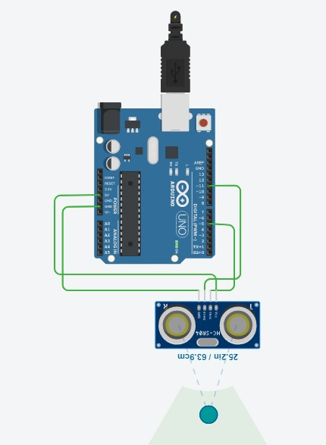

**Concept Used**

1.Concept of the Ultrasonic Sensor.

The obstacle detector works on the principle of transmitting and receiving the Ultrasonic signal, and calculating the distance between the obstacle and the sensor by measuring the time between transmitting and receiving of the signal.

It has various pins-

a.VCC-Powers the module. Connect to +5V Supply voltage.

b.GROUND-Ground pin of module, connect to system ground.

c.TX Transmitter-Transmits Serial Data. Everything received via Bluetooth will be given out by this pin as serial data.

d.RX Receiver-Receive Serial Data. Every serial data given to this pin will be broadcasted via Bluetooth.

2. Method to calculate the distance between the obstacle and the sensor, on the basis of signal transmission and receiving.

3.The concept of the Arduino.

**Learning and Observations**

1.I made the connection between the arduino and the Ultrasonic signal transmitter HC-SR04.

2.The VCC terminal of the ultrasonic sensor is connected to the 5V supply. The TRIG pin is connected to the digital pin 5 and it sends out an ultrasonic wave.

3.ECHO pin is connected to the digital pin 11 and it receives the wave which is reflected back.

4.If the distance between the obstacle and the sensor is greater than 20cm, then the LED glows.

5. Making the circuits using Arduino and other electrical equipment.

6. The working of the Ultrasonic Signal Transmitter IC.

**Problems and Troubleshooting**

1.There was a slight confusion in understanding and then making the required connections.

2.Some minor errors were there, which were trouble shooted by correcting the code.

**Precautions**

1.The connections must be correct.

2. All the equipment must be in working condition.

3.The connections made on the pins of the Arduino must coincide with the codes written on the software.

4.Port selection for Arduino should be correct.

5.The distance of the obstacle from the ultrasonic sensor should not be greater than 400 cm.

**Learning and Outcomes**

1.Using Arduino and other electrical equipment to make circuits.

2.I learnt to perform other experiments similar to this one.

3.The working of the ultrasonic sensor and improvised the learnings and my concepts of Arduino.